Tensile calculation using ML algorithms:

**Experiment Outcomes**:

|  |  |  |  |  |  |  |  |  |
| --- | --- | --- | --- | --- | --- | --- | --- | --- |
| **RPM** | **TS** | **PP** | **AL** | **RPM2** | **TS2** | **PP2** | **AL2** | **Tensile** |
| -1 | -1 | -1 | -1 | 1200 | 40 | 1 | 9 | 356 |
| 1 | -1 | -1 | -1 | 1600 | 40 | 1 | 9 | 394 |
| -1 | 1 | -1 | -1 | 1200 | 80 | 1 | 9 | 343 |
| 1 | 1 | -1 | -1 | 1600 | 80 | 1 | 9 | 381 |
| -1 | -1 | 1 | -1 | 1200 | 40 | -1 | 9 | 368 |
| 1 | -1 | 1 | -1 | 1600 | 40 | -1 | 9 | 396 |
| -1 | 1 | 1 | -1 | 1200 | 80 | -1 | 9 | 354 |
| 1 | 1 | 1 | -1 | 1600 | 80 | -1 | 9 | 397 |
| -1 | -1 | -1 | 1 | 1200 | 40 | 1 | 11 | 386 |
| 1 | -1 | -1 | 1 | 1600 | 40 | 1 | 11 | 422 |
| -1 | 1 | -1 | 1 | 1200 | 80 | 1 | 11 | 374 |
| 1 | 1 | -1 | 1 | 1600 | 80 | 1 | 11 | 412 |
| -1 | -1 | 1 | 1 | 1200 | 40 | -1 | 11 | 393 |
| 1 | -1 | 1 | 1 | 1600 | 40 | -1 | 11 | 428 |
| -1 | 1 | 1 | 1 | 1200 | 80 | -1 | 11 | 382 |
| 1 | 1 | 1 | 1 | 1600 | 80 | -1 | 11 | 418 |
| -2 | 0 | 0 | 0 | 1000 | 60 | 0 | 10 | 306 |
| 2 | 0 | 0 | 0 | 1800 | 60 | 0 | 10 | 426 |
| 0 | -2 | 0 | 0 | 1400 | 20 | 0 | 10 | 398 |
| 0 | 2 | 0 | 0 | 1400 | 100 | 0 | 10 | 352 |
| 0 | 0 | -2 | 0 | 1400 | 60 | -2 | 10 | 397 |
| 0 | 0 | 2 | 0 | 1400 | 60 | 2 | 10 | 411 |
| 0 | 0 | 0 | -2 | 1400 | 60 | 0 | 8 | 384 |
| 0 | 0 | 0 | 2 | 1400 | 60 | 0 | 12 | 423 |
| 0 | 0 | 0 | 0 | 1400 | 60 | 0 | 10 | 452 |
| 0 | 0 | 0 | 0 | 1400 | 60 | 0 | 10 | 443 |
| 0 | 0 | 0 | 0 | 1400 | 60 | 0 | 10 | 440 |
| 0 | 0 | 0 | 0 | 1400 | 60 | 0 | 10 | 438 |
| 0 | 0 | 0 | 0 | 1400 | 60 | 0 | 10 | 444 |
| 0 | 0 | 0 | 0 | 1400 | 60 | 0 | 10 | 447 |

**Variables Summary:**

Heatmap is defined as a graphical representation of data using colors to visualize the value of the matrix. In this, to represent more common values or higher activities brighter colors basically reddish colors are used and to represent less common or activity values, darker colors are preferred. Heatmap is also defined by the name of the shading matrix.

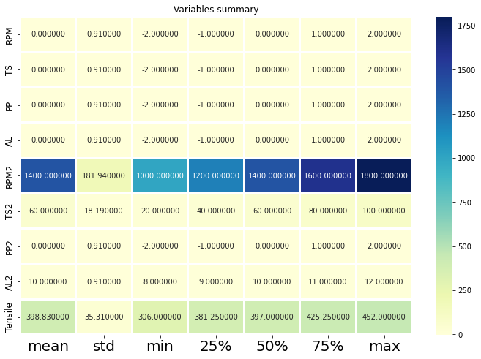

**Displot:**

The distplot represents the univariate distribution of data i.e. data distribution of a variable against the density distribution.

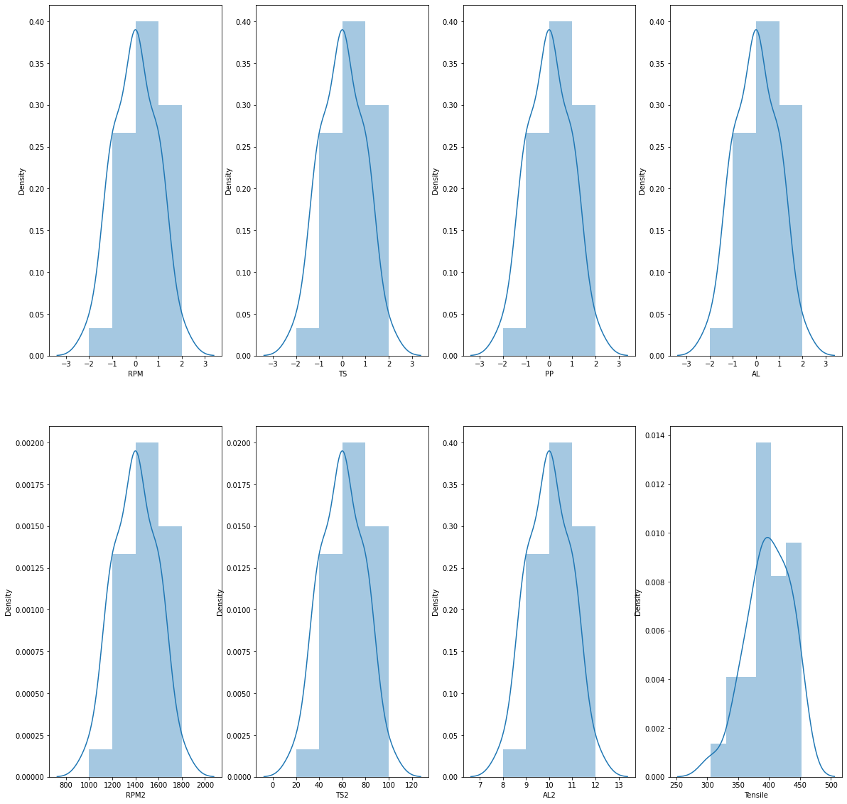

**Pairplot:**

Plot pairwise relationships in a dataset.

By default, this function will create a grid of Axes such that each numeric variable in data will by shared across the y-axes across a single row and the x-axes across a single column. The diagonal plots are treated differently: a univariate distribution plot is drawn to show the marginal distribution of the data in each column.

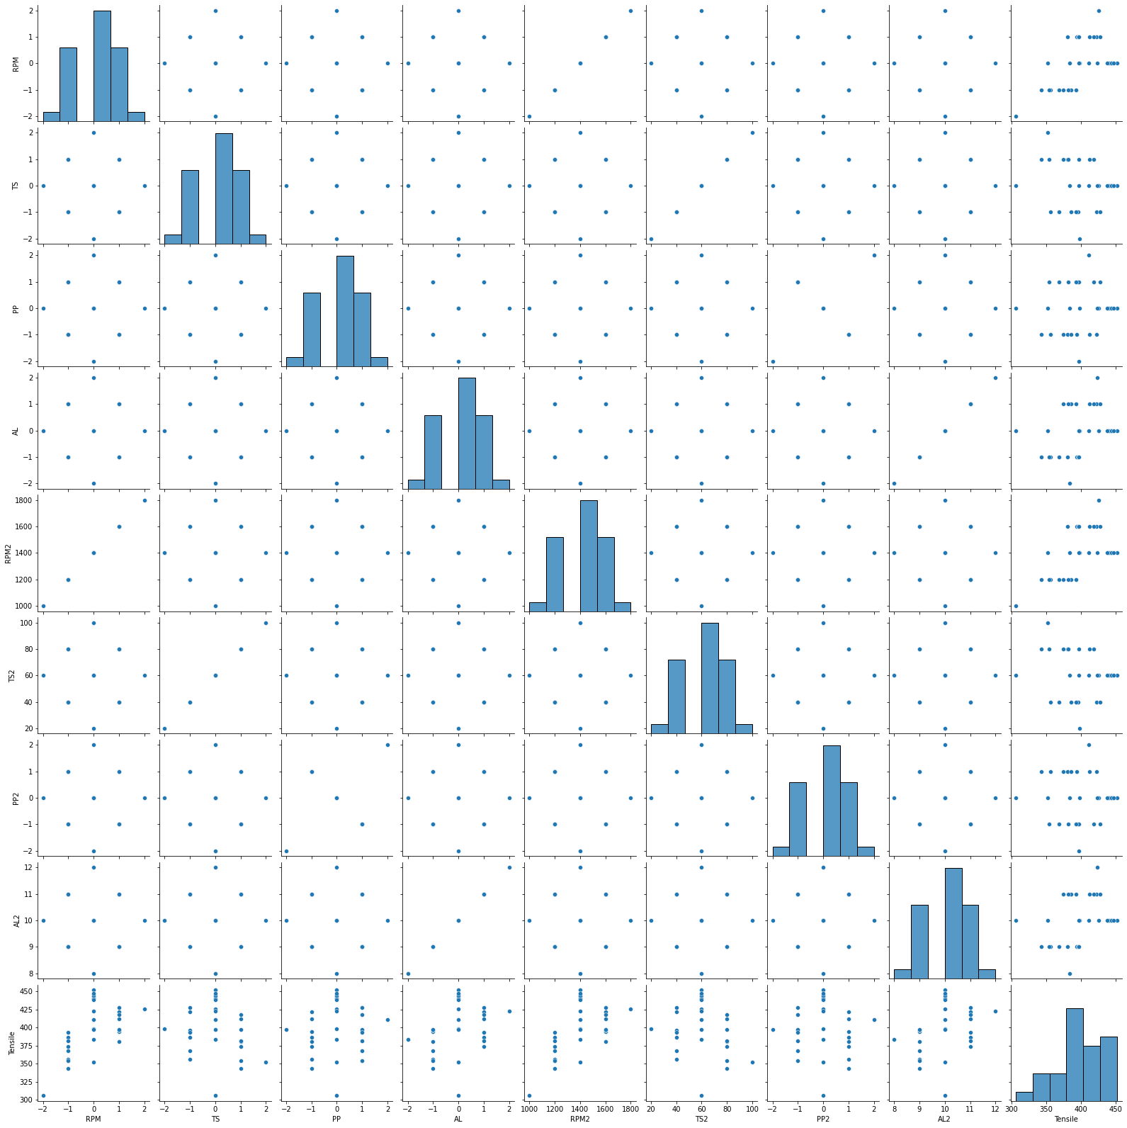

Regplot

regplot function in Seaborn can be used to do this and we’ll look at linear regression that helps us see simple relations in the data and also higher order regressions that show a more complex picture.

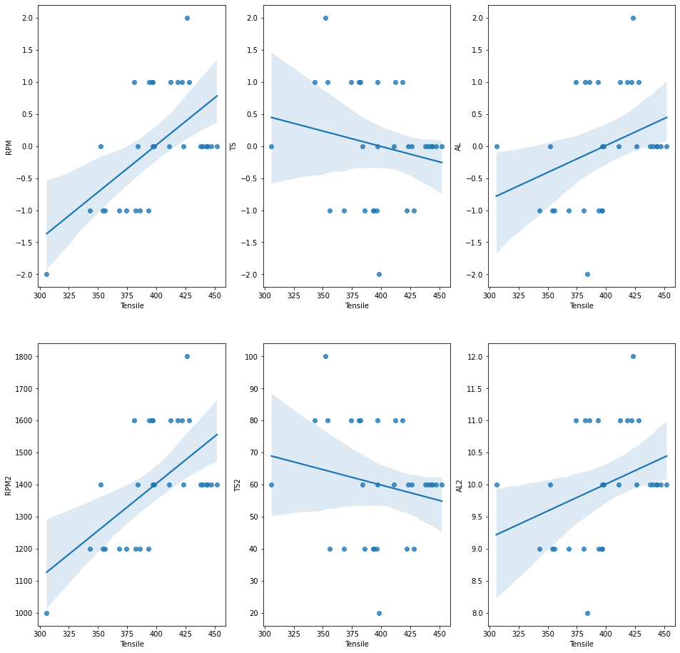

**Correlation between variables:**

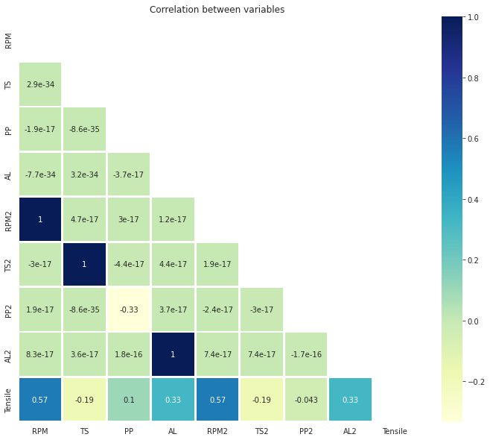

|  |  |  |  |
| --- | --- | --- | --- |
|  | Mean absolute error | Mean squared error | **R2 SCORE** |
| **RandomForestRegressor** | MAE: 7.229 | 55.91 | 0.82 |
| **Decision Tree Regressor** | MAE: 12.733 | 317.61 | 0.01 |
| Support Vector Regression (SVR) | MAE: 24.521 | 896.40 | -1.79 |
| KNeighborsRegressor | MAE: 11.000 | 156.38 | 0.51 |

**ANN**

Model: "sequential_2"

_________________________________________________________________

Layer (type) Output Shape Param #

=================================================================

dense_6 (Dense) (None, 5) 45

dense_7 (Dense) (None, 5) 30

dense_8 (Dense) (None, 1) 6

=================================================================

Total params: 81

Trainable params: 81

Non-trainable params: 0

_________________________________________________________________

None